K Tolliver

Lab 10

1) Using the code provided, run the pcaOutputTest() function and flash an LED on Pin 2 using the appropriate resistor in the circuit.

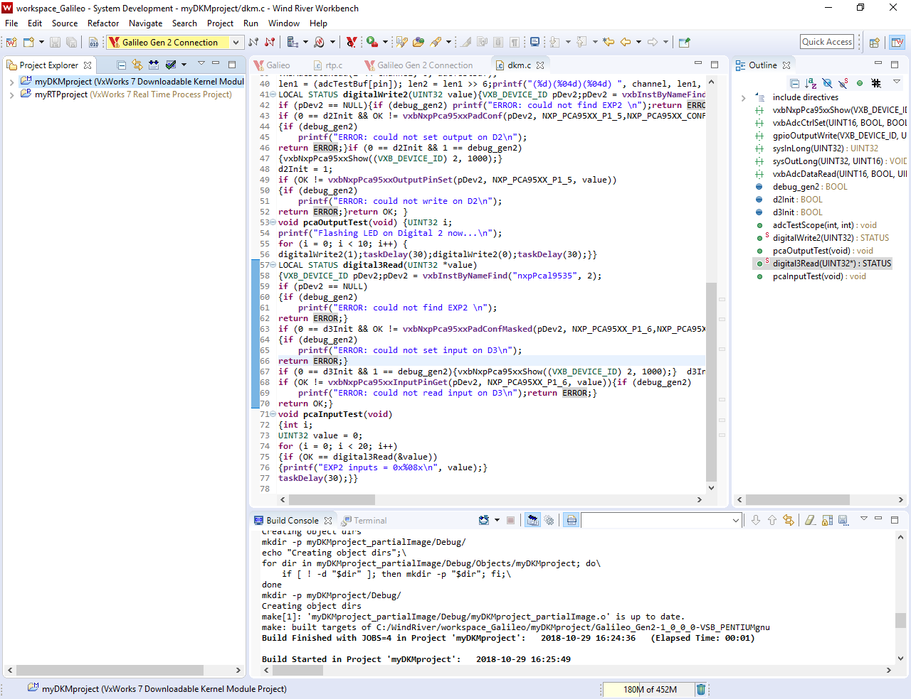

2) Using the code provided, run the pcaInputTest() function and input a voltage from 0 to 5 volts on EXP2, to read a digital input.

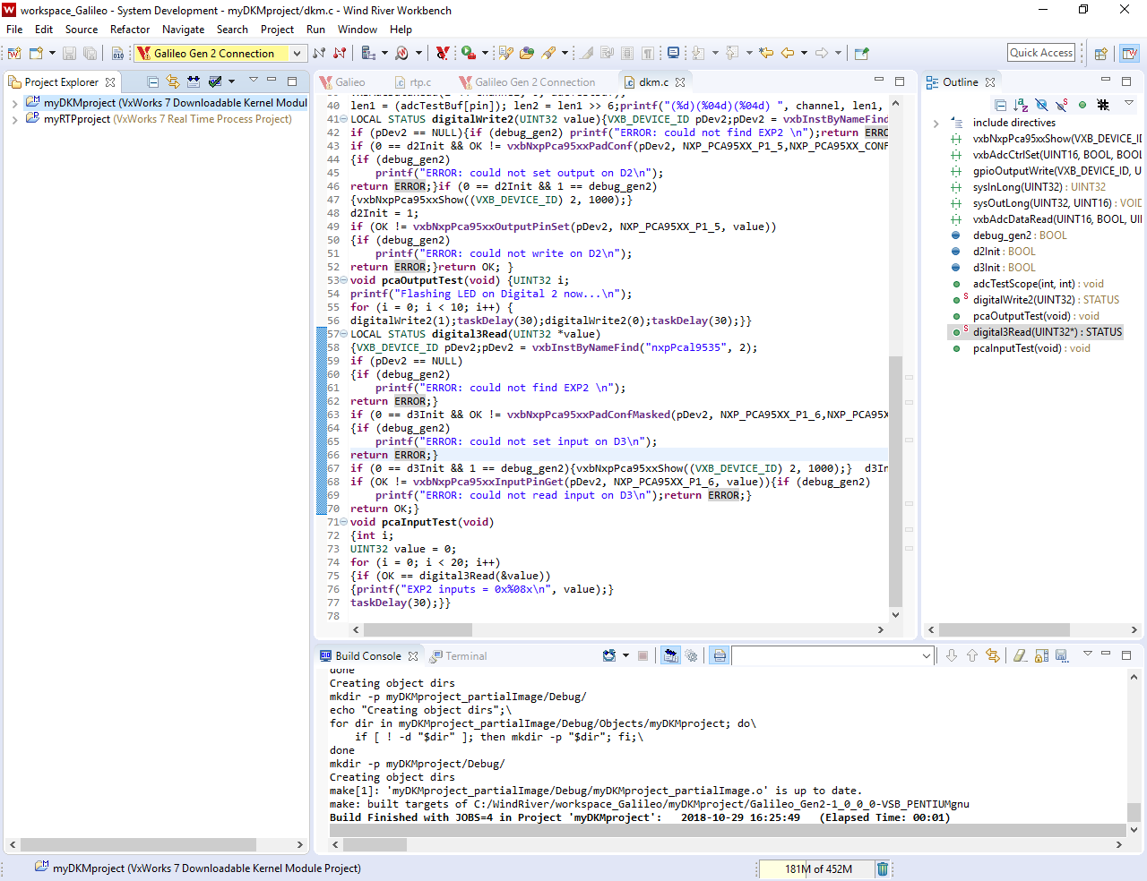

3) Using the code provided, run the adcScopeTest() function to measure an input sine wave.

